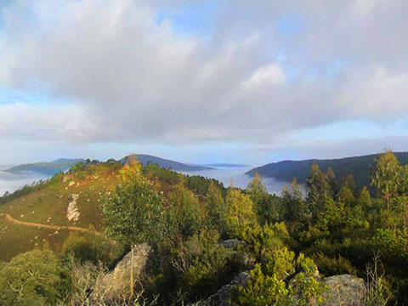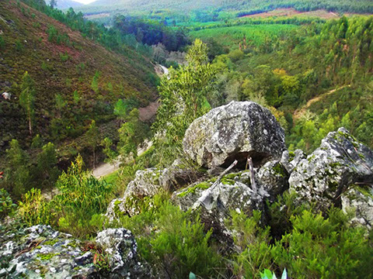

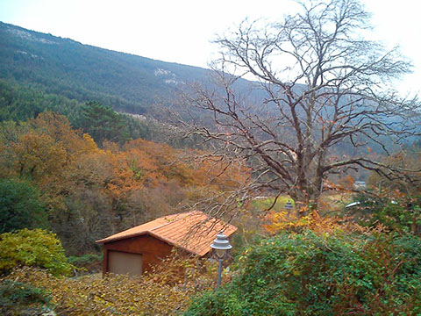

Caminhada Noturna

|  |  |  |  |  |  |  |  |  |  |  |  |  |  |  |  |  |  |  |  |  |  |  |  |  |  |  |  |  |  |  |  |  |  |  |  |  |  |  |  |  |  |  |  |  |  |  |  |  |  |  |  |  |  |  |  |  |  |  |  |  |  |  |  |  |  |  |  |  |  |  |  |  |  |  |  |  |  |  |  |  |  |  |  |  |  |  |  |  |  |  |  |  |  |  |  |  |  |  |  |  |  |  |  |  |  |  |  |  |  |  |  |  |  |  |  |  |  |  |  |  |  |  |  |  |  |  |  |  |  |  |  |  |  |  |  |  |  |  |  |  |
| --- | --- | --- | --- | --- | --- | --- | --- | --- | --- | --- | --- | --- | --- | --- | --- | --- | --- | --- | --- | --- | --- | --- | --- | --- | --- | --- | --- | --- | --- | --- | --- | --- | --- | --- | --- | --- | --- | --- | --- | --- | --- | --- | --- | --- | --- | --- | --- | --- | --- | --- | --- | --- | --- | --- | --- | --- | --- | --- | --- | --- | --- | --- | --- | --- | --- | --- | --- | --- | --- | --- | --- | --- | --- | --- | --- | --- | --- | --- | --- | --- | --- | --- | --- | --- | --- | --- | --- | --- | --- | --- | --- | --- | --- | --- | --- | --- | --- | --- | --- | --- | --- | --- | --- | --- | --- | --- | --- | --- | --- | --- | --- | --- | --- | --- | --- | --- | --- | --- | --- | --- | --- | --- | --- | --- | --- | --- | --- | --- | --- | --- | --- | --- | --- | --- | --- | --- | --- | --- | --- | --- |
| **Ficha de Inscrição** | | | | | | | | | | | | | | | | | | | | | | | | | | | | | | | | | | | | | | | | | | | | | | | | | | | | | | | | | | | | | | | | | | | | | | | | | | | | | | | | | | | | | | | | | | | | | | | | | | | | | | | | | | | | | | | | | | | | | | | | | | | | | | | | | | | | | | | | | | | | |
|  | |  | | | | |  | | |  | | |  | | |  | | | |  | |  | | |  | | |  | | |  | | |  | | |  | | |  | | |  | | |  | | |  | | |  | | |  | | |  | | |  | | |  | | |  | | |  | | |  | | |  | | |  | |  | | |  | | | |  | | | | |  | |  | | |  | | | |  | | | |  | | | |  | | | |  | | |  | | |  | | | | |  | |  | | |  | |  | | |  | | | | |  | | |  |  | |  | | |
| **Nome:** | | | | | | | | | |  | | |  | | | | | | | | | | | | | | | | | | | | | | | | | | | | | | | | | | | | | | | | | | | | | | | | | | | | | | | | | | | | | | | | | | | | | | | | | | | | | | | | | | | | | | |  | | | **Nº Sócio:** | | | | | | | | |  | | | | | | | | | | | | | | |  | | | | | | | | | | | | | | | |  |  | | | |
|  | |  | | | | |  | | |  | | |  | | |  | | | |  | |  | | |  | | |  | | |  | | |  | | |  | | |  | | |  | | |  | | |  | | |  | | |  | | |  | | |  | | |  | | |  | | |  | | |  | | |  | | |  | |  | | |  | | | |  | | | | |  | |  | | |  | | | |  | | | |  | | | |  | | |  | | | |  | | |  | | | | |  | |  | | |  | |  | | |  | | | | |  | | |  |  | |  | | | |
| **Acompanhantes:** | | | | | | | | | | | | | | | | | | | | | |  | | |  | | |  | | |  | | |  | | |  | | |  | | |  | | |  | | |  | | |  | | |  | | |  | | |  | | |  | | |  | | |  | | |  | | |  | | |  | |  | | |  | | | | **Idade** | | | | | | | | | |  | | | |  | | | |  | | | |  | | |  | | | |  | | |  | | | | |  | |  | | |  | |  | | |  | | | | |  | | |  |  | |  | | | |
|  | | | | | | | | | | | | | | | | | | | | | | | | | | | | | | | | | | | | | | | | | | | | | | | | | | | | | | | | | | | | | | | | | | | | | | | | | | | | | | | |  | | | |  | | | | | | | |  | | | | |  | | | | **Nº Sócio:** | | | | |  | | | | | | | | | | | | | | |  | | | | | | | | | | | | | | | |  |  | | | |
|  |  | | | |  | | | |  | | |  | | |  | | |  | | |  | | |  | | |  | | |  | | |  | | |  | | |  | | |  | | |  | | |  | | |  | | |  | | |  | | |  | | |  | |  | | |  | | |  | | |  | | |  | | |  | | |  | | | |  | | | |  | | |  | | |  | | | |  | | | |  | | | | | | | | | |  | | |  | | |  | |  | | | | |  | |  | | |  | | |  | |  | | |  | |  |  | |  | | | |
|  | | | | | | | | | | | | | | | | | | | | | | | | | | | | | | | | | | | | | | | | | | | | | | | | | | | | | | | | | | | | | | | | | | | | | | | | | | | | | |  | | | |  | | | | | | | | | |  | | | |  | | | | **Nº Sócio:** | | | | | |  | | | | | | | | | | | | | | |  | | | | | | | | | | | | | | | | |  |
|  | | |  | | | | |  | | |  | | |  | | |  | |  | | | |  | | |  | | |  | | |  | | |  | | |  | | |  | | |  | | |  | | |  | | |  | | |  | | |  | | |  | | | |  | | |  | | |  | | |  | | |  | | | |  | | |  | | | |  | | |  | | | |  | | |  | | | | |  | | | |  |  | | | | | | |  | | |  | | |  | |  | | | | |  | |  | | |  | | |  | |  | | |  |  |  | | |  | | |
| **Assinatura:** | | | | | | | | | | | | | | | | |  | | | | | | | | | | | | | | | | | | | | | | | | | | | | | | | | | | | | | | | | | | | | | | | | | | | | | | | | | | **Contacto:** | | | | | | | | | | | | | | | | |  | | | | | | | | | | | | | | | | | | | | | | | | | | | | | | **Data:** | | | | | | |  | | | | | | | | | | | | | | |

**SERRA SANTA JUSTA – VALONGO**

O Núcleo Norte do GDC Fidelidade convida os seus associados a passar uma noite diferente no próximo dia 11/07/14 (sexta-feira), fazendo uma caminhada noturna na **SERRA DE SANTA JUSTA – VALONGO** **(Trilho do Paleozóico).**

* **Data:** 11/07/2014, às 21h00.
* **Local:** Serra Santa Justa (Trilho do Paleozóico).
* **Ponto de encontro:** Junto ao Quartel dos Bombeiros Voluntários de Valongo pelas 20h30.
* **Distância:** 11 Km (estimado 3h00 de percurso).
* **Dificuldade:** Grau médio.
* **Idade mínima:** 10 Anos (não excluindo idade inferior, caso aguente o percurso).

**Equipamento necessário:** Lanterna, calçado apropriado para caminhada fora da estrada, vestuário apropriado às condições climatéricas, ceia ligeira e máquina fotográfica (facultativo)

**Esta atividade é gratuita e será acompanhada por um guia especializado.**

**As inscrições deverão ser enviadas para o email:** [**cesar.augusto.ferreira@fidelidade.pt**](mailto:cesar.augusto.ferreira@fidelidade.pt)**, até ao dia 10/07/14.**