**GDC Centro: Visita Buddha Eden e Grutas Mira d’Aire**

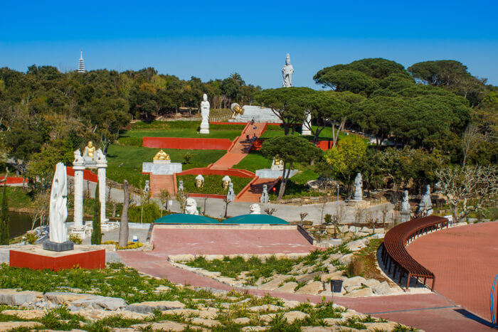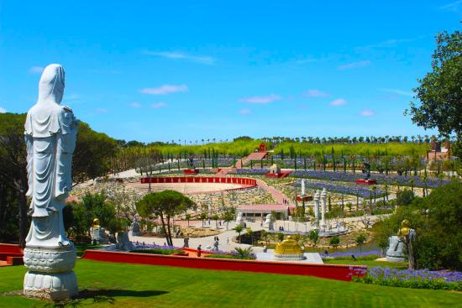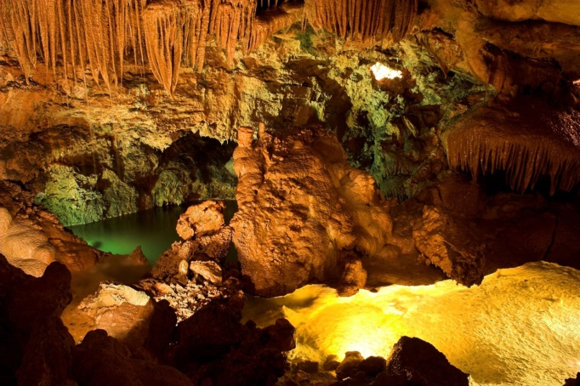

O **Núcleo Centro do** **GDC Fidelidade** organiza no dia **19 de maio** uma visita ao Jardim do Buddha Eden e às grutas de Mira de Aire.

A saída será de Coimbra em autocarro, pelas 8h30 com paragem em Leiria. Às 9h30 será feita uma visita guiada ao Buddha Eden que termina às 13h00 com saída em direcção ao parque das merendas (próximo de Obidos) para um almoço piquenique (partilha obrigatória de especialidades). Às 15h00 o autocarro sai em direcção a mira de Aire para uma visita às grutas por volta das 16h00. Regresso às origens pelas 17h30.

As inscrições deverão ser enviadas para o colega Rui Pinheiro até ao dia **11 de maio**.

Email:[**rui.sousa.pinheiro@fidelidade.pt**](mailto:rui.sousa.pinheiro@fidelidade.pt)

|  |  |
| --- | --- |
| **Sócios** | **Não Sócios** |
| **10,00€** | **17,50€** |
| **Crianças até 12 Anos:** Gratuito | |
| **Mínimo Participantes:** 30 | |
| **Máximo Participantes:** 50 | |

|  |  |  |  |  |  |  |  |  |  |  |  |  |  |  |  |  |  |  |  |  |  |  |  |  |  |  |  |  |  |  |  |  |  |  |  |  |  |  |  |  |  |  |  |  |  |  |  |  |  |  |  |  |  |  |  |  |  |  |  |  |  |  |  |  |  |  |  |  |  |  |  |  |  |  |  |  |  |  |  |  |  |  |  |  |  |  |  |  |  |  |  |  |  |  |  |  |  |  |  |  |  |  |  |  |  |  |  |  |  |  |  |  |  |  |  |  |  |  |  |  |  |  |  |  |  |  |  |  |  |  |
| --- | --- | --- | --- | --- | --- | --- | --- | --- | --- | --- | --- | --- | --- | --- | --- | --- | --- | --- | --- | --- | --- | --- | --- | --- | --- | --- | --- | --- | --- | --- | --- | --- | --- | --- | --- | --- | --- | --- | --- | --- | --- | --- | --- | --- | --- | --- | --- | --- | --- | --- | --- | --- | --- | --- | --- | --- | --- | --- | --- | --- | --- | --- | --- | --- | --- | --- | --- | --- | --- | --- | --- | --- | --- | --- | --- | --- | --- | --- | --- | --- | --- | --- | --- | --- | --- | --- | --- | --- | --- | --- | --- | --- | --- | --- | --- | --- | --- | --- | --- | --- | --- | --- | --- | --- | --- | --- | --- | --- | --- | --- | --- | --- | --- | --- | --- | --- | --- | --- | --- | --- | --- | --- | --- | --- | --- | --- | --- | --- | --- | --- |
| **Ficha de Inscrição** | | | | | | | | | | | | | | | | | | | | | | | | | | | | | | | | | | | | | | | | | | | | | | | | | | | | | | | | | | | | | | | | | | | | | | | | | | | | | | | | | | | | | | | | | | | | | | | | | | | | | | | | | | | | | | | | | | | | | | | | | | | | | | | | | | |
|  | |  | |  | |  |  | | |  | |  | | |  | |  | |  | | |  | |  | |  | |  | | |  | | |  |  | | |  | | |  |  | | |  | | |  | | |  | |  | | |  | | |  | |  | |  | | |  | | | |  | |  | | |  | | |  | | | |  | |  | | | | | | | | | | |  | | | | |  |  | | | |  | | | | | |  | | |  | | | | |  | | |  | | |  | |  | | |  |  | |  | | | | |
| **Nome:** | | | | | |  | | | | | | | | | | | | | | | | | | | | | | | | | | | | | | | | | | | | | | | | | | | | | | | | | | | | | | | | | | | | | | | | | | | | | | | | | | | | | | **Nº Sócio:** | | | | | | | | | | | | | | | | |  | | | | | | | | | | | | | | | | | | | | | | | | | | |  |  | |  | | | | | | | | | | | | | | | | | | | | | | | | | | |
|  | | | | | | | | | | | | | | | | | | |  | | |  | |  | |  | |  | | |  | | |  |  | | |  | | |  |  | | |  | | |  | | |  | |  | | |  | | |  | |  | |  | | |  | | | |  | |  | | |  | | | |  | | |  | |  | | | | | | | | | | |  | | |  | | |  | | | |  | | | | | |  | | |  | | | | |  | | |  | | |  | |  | | |  |  | |  | | | | | | | | | | | | | | | | | | | | | | | | | | | | | | | |
| **Data Nasc:** | | | | | | | | | |  | | | | | | | | | | | | | | | | | | | | | | | | | **NIF:** | | | | | | | | | | | | | |  | | | | | | | | | | | | | | | | | | | | | | | | | | | | | | | | | | |  | | | | | | | | | | | | | |  | | |  | | | |  | | | | | |  | | |  | | | | |  | | |  | | |  | |  | | |  |  | |  | | | | | | | | | | | | | | | | | | | | | | | | | | | | | | | |
|  | |  | |  | |  |  | | |  | |  | | |  | |  | |  | | |  | |  | |  | |  | | |  | | |  |  | | |  | | |  |  | | |  | | |  | | |  | |  | | |  | | |  | |  | |  | | |  | | | |  | |  | | |  | | | |  | | |  | |  | | | | | | | | | | |  | | |  | | |  | | | |  | | | | | |  | | |  | | | | |  | | |  | | |  | |  | | |  |  | |  | | | | | | | | | | | | | | | | | | | | | | | | | | | | | | | |
| **Outros Participantes:** | | | | | | | | | | | | | | | | | | | | | | | | | | | | | | | | | |  |  | | |  | | |  |  | | |  | | |  | | |  | |  | | |  | | |  | |  | |  | | |  | | | |  | |  | | |  | | | |  | | |  | |  | | | | | | | | | | |  | | |  | | |  | | | |  | | | | | |  | | |  | | | | |  | | |  | | |  | |  | | |  |  | |  | | | | | | | | | | | | | | | | | | | | | | | | | | | | | | | |
|  | | | | | | | | | | | | | | | | | | | | | | | | | | | | | | | | | | | | | | | | | | | | | | | | | | | | | | | | | | | | | | | | | | **Data Nasc:** | | | | | | | | | | | | | | | | | |  | | | | | | | | | | | | | | | | | | | | | **Sócio:** | | | | | |  | | | **Sim** | | | | | | | |  | | |  | **Não** | | | |  |  | |  | | | | | | | | | | | | | | | | | | | | | | | | | | | | | | | |
|  | | | | | | | | | | | | | | | | | | | | | | | | | | | | | | | | | | | | | | | | | | | | | | | | | | | | | | | | | | | | | | | | | | | | | | | | | | | | | | | | | |  | |  | | | | | | | | | | |  | | |  | | |  | | | |  | | | | | |  | | |  | | | | |  | | |  | | |  | |  | | |  |  | |  | | | | | | | | | | | | | | | | | | | | | | | | | | | | | | | |
|  | | | | | | | | | | | | | | | | | | | | | | | | | | | | | | | | | | | | | | | | | | | | | | | | | | | | | | | | | | | | | | | | | | **Data Nasc:** | | | | | | | | | | | | | | | | | |  | | | | | | | | | | | | | | | | | | | | | **Sócio:** | | | | | |  | | | **Sim** | | | | | | | |  | | |  | **Não** | | | |  |  | |  | | | | | | | | | | | | | | | | | | | | | | | | | | | | | | | |
|  | | | | | | | | | | | | | | | | | | | | | | | | | | | | | | | | | | | | | | | | | | | | | | | | | | | | | | | | | | | | | | | | | | | | | | | | | | | | | | | | | |  | |  | | | | | | | | | | |  | | |  | | |  | | | |  | | | | | |  | | |  | | | | |  | | |  | | |  | |  | | |  |  | |  | | | | | | | | | | | | | | | | | | | | | | | | | | | | | | | |
| **Email:** | | | | | |  | | | | | | | | | | | | | | | | | | | | | | | | | | | | | | | | | | | | | | | | | | | | | | | | | | | | | | | | | | | | | | | | | | | | | | |  | | | | | | | | | | | | | | |  | | | |  | | | | | | |  | | | |  | | | | |  | | | | |  | | | | | |
|  | | | | | | | | |  | | | |  | | |  | | | |  | | |  | | |  | | |  | | |  | | | | |  | | |  | | |  | | |  | | | |  | | | |  | | |  | | |  | | | |  | | | |  | | |  | | |  | | |  | | | |  | | | |  | |  | |  | |  | | |  | | | | |  | | | |  | | | |  | | |  | | | | | |  | | | |  | | |  | | | | | | | | | | | |  | |  | | | | |  | |  | | |  | |  | |  | |  | |  | |  | | |  | |  | |  |
| **Pagamento:** | | | | | | | | | | **Venc.** | | | | | | | | | | | | | | | |  | | | **Numerário** | | | | | | | | | | | | | | | | | | | | | | | | |  | | | **T. B. – PT50003501100000700893025** | | | | | | | | | | | | | | | | | | | | | | | | | | | | | | | | | | | | | | | | | | | | | | | | | | | | | | |  | | | | | | | |  | | | | | | | | | | | | | | | | | | | |  | | |  | |
|  | | |  | |  | | |  | | |  | | |  | | | |  | | |  | | | |  | |  | | |  | | |  | | |  | | |  | | | | |  | | |  | | | | |  | | |  | | |  | | | |  | | |  | | | |  | | | |  | | |  | | | |  | | | | | |  | |  | |  | |  | | | |  | | | | | |  | | | |  | | |  | | | | | | | |  | | | |  | | | | | | | | | | |  | | | |  | | |  | |  | | | | |  | |  | |  | |  | |  | |  | | |  | |  | |  | |
| **Assinatura:** | | | | | | | | | |  | | | | | | | | | | | | | | | | | | | | | | | | | | | | | | | | | | | | | | | | | | | | | | | | | | | | | | | | | **Telemóvel:** | | | | | | | | | | | | | | | |  | | | | | | | | | | | | | | | | | | | | | | | **Data:** | | | | | | | | |  | | | | | | | | | | | | | | | | |  | |