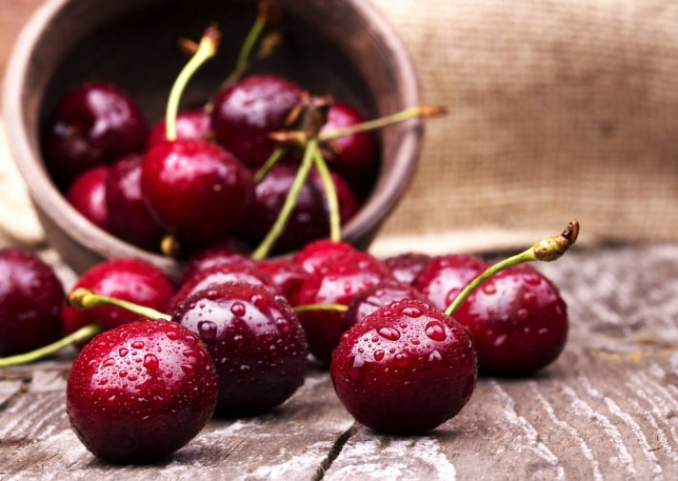**Núcleo Centro: Convívio com Cerejas**

O **Núcleo Centro** do **GDC Fidelidade** organiza no dia **30 de junho** (sábado) um convívio com cerejas no Fundão.

A saída do autocarro será pelas **8h30**, junto à Área de Mediação de Coimbra, com paragens em Avelar e Castelo Branco para recolher os participantes. Após a chegada ao Fundão, seguiremos para uma divertida e tradicional apanha da cereja. Terminando a atividade, seguiremos para a Gardunha para um **almoço** onde convidamos os participantes a trazer especialidades da sua zona para partilhar entre o grupo.

Da parte da tarde convidamos o grupo a visitar os pomares da Gardunha e o miradouro da Casa da Guarda.

No final do dia é hora de voltar a Coimbra.

**As inscrições deverão ser enviadas a partir das 10h00, do dia 17 de maio (Quinta-feira), para o email do** [**miguel.bernardes.chula@fidelidade.pt**](mailto:miguel.bernardes.chula@fidelidade.pt)

|  |  |  |  |  |  |  |  |  |  |  |  |  |  |  |  |  |  |  |  |  |  |  |  |  |  |  |  |  |  |  |  |  |  |  |  |  |  |  |  |  |  |  |  |  |  |  |  |  |  |  |  |  |  |  |  |  |  |  |  |  |  |  |  |  |  |  |  |  |  |  |  |  |  |  |  |  |  |  |  |  |  |  |  |  |  |  |  |  |  |  |  |  |  |  |  |  |  |  |  |  |  |  |  |  |  |  |  |  |  |  |  |  |  |  |  |  |  |  |  |  |  |  |  |  |  |  |  |  |  |  |  |  |  |  |  |  |  |  |  |  |  |  |  |  |  |  |  |  |  |  |  |  |  |  |  |  |  |  |
| --- | --- | --- | --- | --- | --- | --- | --- | --- | --- | --- | --- | --- | --- | --- | --- | --- | --- | --- | --- | --- | --- | --- | --- | --- | --- | --- | --- | --- | --- | --- | --- | --- | --- | --- | --- | --- | --- | --- | --- | --- | --- | --- | --- | --- | --- | --- | --- | --- | --- | --- | --- | --- | --- | --- | --- | --- | --- | --- | --- | --- | --- | --- | --- | --- | --- | --- | --- | --- | --- | --- | --- | --- | --- | --- | --- | --- | --- | --- | --- | --- | --- | --- | --- | --- | --- | --- | --- | --- | --- | --- | --- | --- | --- | --- | --- | --- | --- | --- | --- | --- | --- | --- | --- | --- | --- | --- | --- | --- | --- | --- | --- | --- | --- | --- | --- | --- | --- | --- | --- | --- | --- | --- | --- | --- | --- | --- | --- | --- | --- | --- | --- | --- | --- | --- | --- | --- | --- | --- | --- | --- | --- | --- | --- | --- | --- | --- | --- | --- | --- | --- | --- | --- | --- | --- | --- | --- | --- | --- |
| **Ficha de Inscrição** | | | | | | | | | | | | | | | | | | | | | | | | | | | | | | | | | | | | | | | | | | | | | | | | | | | | | | | | | | | | | | | | | | | | | | | | | | | | | | | | | | | | | | | | | | | | | | | | | | | | | | | | | | | | | | | | | | | | | | | | | | | | | | | | | | | | | | | | | | | | | | | | | | | | | | | | | | | | | | |
|  | |  | | |  | | |  | | |  | | |  | | |  | | |  | | |  | | |  | | |  | | |  | | |  | | |  | | |  | | |  | | |  | | |  | | |  | | |  | | |  | | |  | | |  | |  | | |  | | |  | | |  | | |  | | | |  | | | |  | | | |  | | |  | | |  | | | |  | | | |  | | | |  | | | |  | | |  | | |  | | | | |  | |  | | |  | | | |  | | |  | | | | |  | | | | | |  |  | | |  | | | | | |
| **Nome:** | | | | | | | |  | | |  | | | | | | | | | | | | | | | | | | | | | | | | | | | | | | | | | | | | | | | | | | | | | | | | | | | | | | | | | | | | | | | | | | | | | | | | | | | | | | | | | | | | | | |  | | | | **Nº Sócio:** | | | | | | | | |  | | | | | | | | | | | | | | | **Não Sócio:** | | | | | | | | | | | | | | | | | | | | |  | | |  | | | | | | | | | |
|  | |  | | |  | | |  | | |  | | |  | | |  | | |  | | |  | | |  | | |  | | |  | | |  | | |  | | |  | | |  | | |  | | |  | | |  | | |  | | |  | | |  | | |  | |  | | |  | | |  | | |  | | |  | | | |  | | | |  | | | |  | | |  | | |  | | | |  | | | |  | | | |  | | |  | | | |  | | |  | | | | |  | |  | | |  | | | |  | | |  | | | | |  | | | | | |  | | |  | | | |  | | | | | | |
| **Acompanhantes:** | | | | | | | | | | | | | | | | | | | |  | | |  | | |  | | |  | | |  | | |  | | |  | | |  | | |  | | |  | | |  | | |  | | |  | | |  | | |  | | |  | |  | | |  | | |  | | |  | | |  | | | |  | | | | **Idade** | | | | | | | | | |  | | | |  | | | |  | | | |  | | |  | | | |  | | |  | | | | |  | |  | | |  | | | |  | | |  | | | | |  | | | | | |  | | |  | | | |  | | | | | | |
|  | | | | | | | | | | | | | | | | | | | | | | | | | | | | | | | | | | | | | | | | | | | | | | | | | | | | | | | | | | | | | | | | | | | | | | | | | | | | | | | | | | | |  | | | |  | | | | | | | | |  | | | | |  | | | | **Nº Sócio:** | | | | |  | | | | | | | | | | | | | | | **Não Sócio:** | | | | | | | | | | | | | | | | | | | | |  | | |  | | | | | | | | | |
|  |  | | |  | | |  | | |  | | |  | | |  | | |  | | |  | | |  | | |  | | |  | | |  | | |  | | |  | | |  | | |  | | |  | | |  | |  | | |  | | |  | | |  | | |  | | |  | | |  | | |  | | |  | | | |  | | | |  | | | |  | | |  | | |  | | | |  | | | |  | | | | | | | | | |  | | |  | | |  | |  | | | | |  | | |  | | | |  | | |  | | |  | | | | |  | | | |  | | | |  | | |  | | | | |
|  | | | | | | | | | | | | | | | | | | | | | | | | | | | | | | | | | | | | | | | | | | | | | | | | | | | | | | | | | | | | | | | | | | | | | | | | | | | | | | | | | |  | | | |  | | | | | | | | | |  | | | |  | | | | **Nº Sócio:** | | | | | |  | | | | | | | | | | | | | | | **Não Sócio:** | | | | | | | | | | | | | | | | | | | | | |  | |
|  |  | | |  | | |  | | |  | | |  | | |  | | |  | | |  | | |  | | |  | | |  | | |  | | |  | | |  | | |  | | |  | | |  | | |  | |  | | |  | | |  | | |  | | |  | | |  | | |  | | |  | | |  | | | |  | | | |  | | | |  | | |  | | |  | | | |  | | | |  | | | | | | | | | |  | | |  | | |  | |  | | | | |  | | |  | | | |  | | |  | | |  | | |  | | | | | |  | | | |  | | |  | | | | |
| **Pagamento:** | | | | | | | | | | | | | **Dinheiro** | | | | | | | | | | | | | | | | | | | | | | | | | | | | | |  | | | **Cheque** | | | | | | | | | | | | | | | | | | | | | | | | | | | | | | | | | | |  | | | | |  | | | | | | | | | | | | | | | | | | | | | | | | | | | | | | | | | | | | | | | | | | | | | |  | | | | | |  | | | | | |  | | |
|  | | |  | | |  | | |  | | |  | | |  | | |  | | |  | | |  | | |  | | |  | | |  | | |  | | |  | | |  | | |  | | |  | | |  | | | |  | | |  | | |  | | |  | | | |  | | |  | | |  | | |  | | |  | | | | |  | | | |  | | |  | | |  | | | |  | | | |  | | | |  |  | | | | | | |  | | |  | | |  | |  | | | | |  | | |  | | | |  | | | |  | | |  | | | |  | | | | | |  | | |  | | |  | | |
| **Assinatura:** | | | | | | | | | | | | | | |  | | | | | | | | | | | | | | | | | | | | | | | | | | | | | | | | | | | | | | | | | | | | | | | | | | | | | | | | | | | **Contacto:** | | | | | | | | | | | | | | | | | |  | | | | | | | | | | | | | | | | | | | | | | | | | | | | | **Data:** | | | | | | | | | |  | | | | | | | | | | | | | | | | | | | | | | | |  | | |  | | |

|  |  |  |
| --- | --- | --- |
| **Preços por Pessoa** | **Sócios** | **Não Sócios** |
| **Adultos** | **10,00€** | **15,00€** |
| **Crianças até 12 anos** | **Gratuito** | |

**Nº Mínimo de Participantes: 20 pessoas**

**Nº Máximo de Participantes: 30 pessoas**

**Data Limite de Inscrições: 20 de junho de 2018**