**O QUEBRA-NOZES – RUSSIAN CLASSICAL BALLET**

[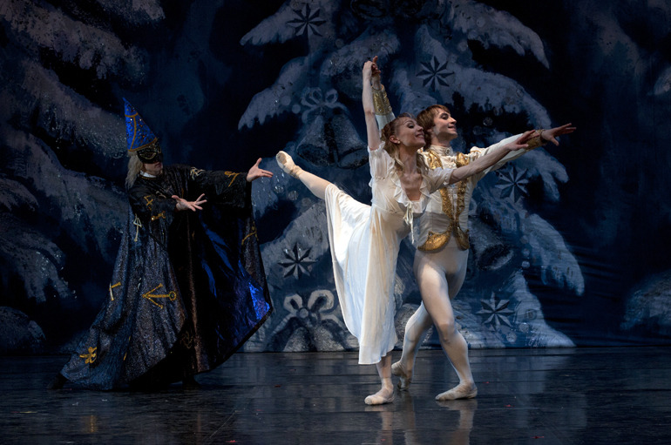](http://www.centrocultural.cm-ilhavo.pt/uploads/event/image/722/quebra-nozes.jpg)

**O Núcleo Sul do GDC Fidelidade**, vai adquirir bilhetes para o espetáculo “ O Quebra – Nozes e o Rei dos Ratos”, que se realiza no Arena d'Évora no **dia 11 de Dezembro (Sexta-feira)**, às **21h30**. O espectáculo destina-se a maiores de 6 anos e tem a duração de 120 minutos (c/intervalo).

Um magnífico bailado clássico que vai encantar o público, com a aclamada e prestigiada companhia RUSSIAN CLASSICAL BALLET, liderada por EVGENIYA BESPALOVA e composta por um elenco de estrelas da dança Internacional.

As inscrições poderão ser enviadas a partir de hoje para o email [rita.sousa.nobre@fidelidade.pt](mailto:rita.sousa.nobre@fidelidade.pt) ou [alvaro.reis.paraiso@fidelidade.pt](mailto:alvaro.reis.paraiso@fidelidade.pt), até ao dia **27/11/15**.

Apenas se realizará se houver no mínimo 20 participantes inscritos.

|  |  |  |
| --- | --- | --- |
| **Valores** | | |
| **Lugares** | **Sócios** | **Público em Geral** |
| **1ª Plateia** | **17,50 €** | **22,50€** |
| **2ª Plateia** | **15,25 €** | **20,25 €** |

|  |  |  |  |  |  |  |  |  |  |  |  |  |  |  |  |  |  |  |  |  |  |  |  |  |  |  |  |  |  |  |  |  |  |  |  |  |  |  |  |  |  |  |  |  |  |  |  |  |  |  |  |  |  |  |  |  |  |  |  |  |  |  |  |  |  |  |  |  |  |  |  |  |  |  |  |  |  |  |  |  |  |  |  |  |  |  |  |  |  |  |  |  |  |  |  |  |  |  |  |  |  |  |  |  |  |  |  |  |  |  |  |  |  |  |  |  |  |  |  |  |  |  |  |  |  |  |  |  |  |  |
| --- | --- | --- | --- | --- | --- | --- | --- | --- | --- | --- | --- | --- | --- | --- | --- | --- | --- | --- | --- | --- | --- | --- | --- | --- | --- | --- | --- | --- | --- | --- | --- | --- | --- | --- | --- | --- | --- | --- | --- | --- | --- | --- | --- | --- | --- | --- | --- | --- | --- | --- | --- | --- | --- | --- | --- | --- | --- | --- | --- | --- | --- | --- | --- | --- | --- | --- | --- | --- | --- | --- | --- | --- | --- | --- | --- | --- | --- | --- | --- | --- | --- | --- | --- | --- | --- | --- | --- | --- | --- | --- | --- | --- | --- | --- | --- | --- | --- | --- | --- | --- | --- | --- | --- | --- | --- | --- | --- | --- | --- | --- | --- | --- | --- | --- | --- | --- | --- | --- | --- | --- | --- | --- | --- | --- | --- | --- | --- | --- | --- | --- |
| **Ficha de Inscrição** | | | | | | | | | | | | | | | | | | | | | | | | | | | | | | | | | | | | | | | | | | | | | | | | | | | | | | | | | | | | | | | | | | | | | | | | | | | | | | | | | | | | | | | | | | | | | | | | | | | | | | | | | | | | | | | | | | | | | | | | | | | | | | | | | | |
|  | | |  | |  | |  |  | | |  | |  | | |  | |  | |  | | |  | |  | |  | | |  | | |  | | |  |  | |  | | | |  |  | | |  | | |  | |  | |  | | |  | | |  |  | | |  | | |  | | | |  | | |  | |  | | |  | | | | |  | |  | | | | | | | | |  | | | | |  | | |  | | |  | | | | | |  | |  | | | |  | | |  | |  |  |  | | | | | |  | | |  | | | | | | |
| **Nome:** | | | | | | |  |  | | | | | | | | | | | | | | | | | | | | | | | | | | | | | | | | | | | | | | | | | | | | | | | | | | | | | | | | | | | | | | | | | | | | | | |  | | | | | **Nº Sócio:** | | | | | | | | | | | | |  | | | | | | | | | | | | | | | | | | | | **Não Sócio:** | | | | | | | |  | | |  | | | | | | | |  | | | | | | | | | | | | | | | | | | | | | | | | | | | | | | | | | | | | | | | | | | | | | | | | | | | | | | | | |
|  | | |  | |  | |  |  | | |  | |  | | |  | |  | |  | | |  | |  | |  | | |  | | |  | | |  |  | |  | | | |  |  | | |  | | |  | |  | |  | | |  | | |  |  | | |  | | |  | | | |  | | |  | |  | | | |  | | | |  | |  | | | | | | | | |  | | | |  | | | |  | | |  | | | | | |  | |  | | | |  | | |  | |  |  |  | | | | | |  | | |  | | | | | | | | | | | | | | | | | | | | | | | | | | | | | | | | | | | | | | | | | |
| **Outros participantes a inscrever:** | | | | | | | | | | | | | | | | | | | | | | | | | | | | | | | | | | | | | | | | | | | | | | | | | |  | |  | |  | | |  | | |  |  | | |  | | |  | | | |  | | |  | |  | | | |  | | | |  | |  | | | | | | | | |  | | | |  | | | |  | | |  | | | | | |  | |  | | | |  | | |  | |  |  |  | | | | | |  | | |  | | | | | | | | | | | | | | | | | | | | | | | | | | | | | | | | | | | | | | | | | |
|  | | | | | | | | | | | | | | | | | | | | | | | | | | | | | | | | | | | | | | | | | | | | | | | | | | | | | | | | | | | | | | | | | | | | | | | | | | | | | | | **Nº Sócio:** | | | | | | | | | | | | | | | | |  | | | | | | | | | | | | | | | | | | | | **Não Sócio:** | | | | | | | |  | | |
|  | | | | | | | | | |  | | | | |  | |  | | | |  | | |  | | | |  | | |  | | |  | | | | | |  | |  | | |  | | |  | | |  | | | |  | | |  | | | |  | | |  | | | |  | | |  | | |  | | |  | | | | | |  | | |  | |  |  | |  | |  | | | | | | |  | | |  | | |  | |  | | | | | | |  | | |  | | |  | | | | | | | | | | |  | | | | |  | | | |  | |  | | | | | |  | | |  | | |  | | |  | | |  | |  | | | | |  |  | | | |  | | | | | | | | | | | | | | | | | | |
|  | | | | | | | | | | | | | | | | | | | | | | | | | | | | | | | | | | | | | | | | | | | | | | | | | | | | | | | | | | | | | | | | | | | | | | | | | | | | **Nº Sócio:** | | | | | | | | | | | | | | | | | | | |  | | | | | | | | | | | | | | | | | | **Não Sócio:** | | | | | | | | | |  | | |  | | | | | |  | | |  | | | |  | |  | | | | | |  | | |  | | |  | | |  | | |  | |  | | | | |  |  | | | |  | | | | | | | | | | | | | | | | | | |
|  | | | | | | | | | | | | | | | | | | | | | | | | | | | | | | | | | | | | | | | | | | | | | | | | | | | | | | | | | | | | | | | | | | | | | | | | | | | | | | | | | |  | | | | | | | | | | | | | | | | | | | | | | | | | | | |  |  | | | | | | | | | | | | | | | | | | | | | | | | | | | |  | | | |  | |  |  | |  | | |  | | |  | | |  | | |  | | |  | |  | |  | |  | | |  |  | |  | |  |  |  |  |  |  |  |  |  |  |  |  |  |  |  |  |
|  | | | |  | |  | | |  | | |  | |  | | | | |  | | |  | | | |  | | |  | | |  | | |  | | |  | | |  | | | | |  | | |  | | | |  | | |  | | |  | | | |  | | |  | | | |  | | |  | | | |  | | | |  | | | |  | | |  | | |  | |  | | |  | | | | | |  | | |  | | |  | | | | | | |  | | | | |  | | | | | | |  | | | | |  | | | | |  | | |  | | | | | | |  | |  | | |  | | |  | | |  | | |  | | | | |  | |  | | |  | | | | | | | | | | | | | | | | | | | | | |
| **Email:** | | | | | | | | | | |  | | | | | | | | | | | | | | | | | | | | | | | | | | | | | | | | | | | | | | | | | | | | | | | | | | | | | | | | | | | | | | | | | | | | | |  | | | | | | |  | | |  | |  | | |  | | | | | |  | | |  | | |  | | | | | | |  | | | | |  | | | | | | |  | | | | |  | | | | |  | | |  | | | | | | |  | |  | | |  | | |  | | |  | | |  | | | | |  | |  | | |  | | | | | | | | | | | | | | | | | | | | | |
|  | | | |  | |  | | |  | | |  | |  | | | | |  | | |  | | | |  | | |  | | |  | | |  | | |  | | |  | | | | |  | | |  | | | |  | | |  | | |  | | | |  | | |  | | | |  | | |  | | | |  | | | |  | | | |  | | |  | | |  | |  | | |  | | | | | |  | | |  | | |  | | | | | | |  | | | | |  | | | | | | |  | | | | |  | | | | |  | | |  | | | | | | |  | |  | | |  | | |  | | |  | | |  | | | | |  | |  | | |  | | | | | | | | | | | | | | | | | | | | | |
| **Assinatura:** | | | | | | | | | | |  | | | | | | | | | | | | | | | | | | | | | | | | | | | | | | | | | | | | | | | | | | | | | | | | | | | | | | | | | **Contacto:** | | | | | | | | | | | | | | |  | | | | | | | | | | | | | | | | | | | | | | **Data:** | | | | | | | |  | | | | | | | | | | | | | |  | | |