**Clube Júnior: Praia e Campo da Roda Viva - 2019**

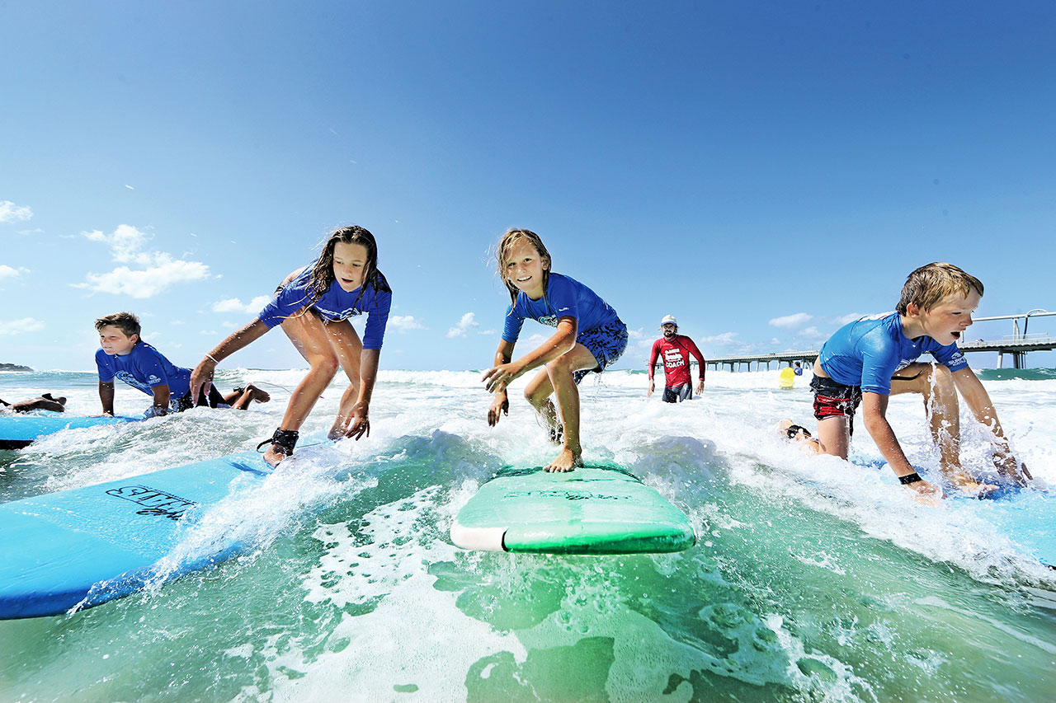

**O Clube Júnior** propõe um programa de 5 ou 10 dias na **Colónia Aberta Praia Campo da Roda Viva**.

**Data do turno:** **julho**: 15 a 19; 22 a 26; 29 a 02 **agosto**; 05 a 09; 12 a 16; 19 a 23; 26 a 30; **setembro** 02 a 06.

**Horário:** Das 8h30 às 17h30 – Ponto de encontro a combinar.

**Local:** Praias diversas

**Quem pode participar:** Filhos e netos de todos os **sócios** dos **6 aos 14 anos**

**O que inclui:** Transporte, diversas atividades (manhãs na praia, cheias de jogos e brincadeiras, mergulhos e aulas de surf, tardes temáticas, bodyboard, escalada, stand-up-paddle, passeio de varino, foot-paper, bairrista, desfile de marchas, piscina de ondas)

**Não inclui:** Alimentação

**Nota**: Esta colónia apenas se realizará se tiver no **mínimo 20 participantes.**

Lembramos que se por algum motivo houver necessidade de **desistir** teremos que ficar sujeitos às condições impostas pela Colónia/Campo de Férias.

**O pagamento pode ser fracionado em 3 meses (de maio a julho). Os associados que não optem pelo desconto no vencimento terão de finalizar o pagamento até à data de início da Praia e Campo.**

A inscrição deverá ser enviada para: [grupo.desportivo.reservas@fidelidade.pt](mailto:grupo.desportivo.reservas@fidelidade.pt)

|  |  |  |  |  |  |  |  |  |  |  |  |  |  |  |  |  |  |  |  |  |  |  |  |  |  |  |  |  |  |  |  |  |  |  |  |  |  |  |  |  |  |  |  |  |  |  |  |  |  |  |  |  |  |  |  |  |  |  |  |  |  |  |  |  |  |  |  |  |  |  |  |  |  |  |  |  |  |  |  |  |  |  |  |  |  |  |  |  |  |  |  |  |  |  |  |  |  |  |  |  |  |  |  |  |  |  |  |  |  |  |  |  |  |  |  |  |  |  |  |  |  |  |  |  |  |  |  |  |  |  |  |  |  |  |  |  |  |  |  |  |  |  |  |  |  |  |  |  |  |  |  |  |  |  |  |  |  |  |  |  |  |  |  |  |  |  |  |  |  |  |  |  |  |  |  |  |  |  |  |  |  |  |  |  |  |  |  |  |  |  |  |  |  |  |  |
| --- | --- | --- | --- | --- | --- | --- | --- | --- | --- | --- | --- | --- | --- | --- | --- | --- | --- | --- | --- | --- | --- | --- | --- | --- | --- | --- | --- | --- | --- | --- | --- | --- | --- | --- | --- | --- | --- | --- | --- | --- | --- | --- | --- | --- | --- | --- | --- | --- | --- | --- | --- | --- | --- | --- | --- | --- | --- | --- | --- | --- | --- | --- | --- | --- | --- | --- | --- | --- | --- | --- | --- | --- | --- | --- | --- | --- | --- | --- | --- | --- | --- | --- | --- | --- | --- | --- | --- | --- | --- | --- | --- | --- | --- | --- | --- | --- | --- | --- | --- | --- | --- | --- | --- | --- | --- | --- | --- | --- | --- | --- | --- | --- | --- | --- | --- | --- | --- | --- | --- | --- | --- | --- | --- | --- | --- | --- | --- | --- | --- | --- | --- | --- | --- | --- | --- | --- | --- | --- | --- | --- | --- | --- | --- | --- | --- | --- | --- | --- | --- | --- | --- | --- | --- | --- | --- | --- | --- | --- | --- | --- | --- | --- | --- | --- | --- | --- | --- | --- | --- | --- | --- | --- | --- | --- | --- | --- | --- | --- | --- | --- | --- | --- | --- | --- | --- | --- | --- | --- | --- | --- | --- | --- | --- | --- | --- |
| **Ficha de Inscrição – Praia e Campo Roda Viva 2019** | | | | | | | | | | | | | | | | | | | | | | | | | | | | | | | | | | | | | | | | | | | | | | | | | | | | | | | | | | | | | | | | | | | | | | | | | | | | | | | | | | | | | | | | | | | | | | | | | | | | | | | | | | | | | | | | | | | | | | | | | | | | | | | | | | | | | | | | | | | | | | | | | | | | | | | | | | | | | | | | | | | | | | | | | | | | | | | | | | | | | | | | | | | | | | | | | | | |
|  | | | |  | | | | | |  | | | |  | | | |  | | | | |  | | | | | | |  | |  | | | |  | | | |  | | | |  | | | | |  | | | |  | | | |  | | | |  | | | |  | | | |  | | | | |  | | |  | | |  | | |  | | |  | | |  | | |  | | |  | | |  | | | |  | | |  | | |  | | | |  | | |  | |  | | | |  | | | |  | | | | | | |  | | | | | | | |  | | |  | | |  | | | |  | | | | | | | | |  |  | | | | |  | | |  | | | |  | | | | | | |  | | | | | | | |  | | |  | | |  | | | |
| **Nome:** | | | | | | | | | | | | | | | | | | | | |  | | | | |  | | | | | | | | | | | | | | | | | | | | | | | | | | | | | | | | | | | | | | | | | | | | | | | | | | | | | | | | | | | | | | | | | | | | | | | | | | | | | | | | | | | | | | | | | | | | |  | | | | | | | **Nº Colab.:** | | | | | | | | | | | | | | |  | | | | | | | | | | | | | | | | | | | **(Obrigatório)** | | | | | | | | | | | | | | | | | | | | | | | | | | |  | | | | |  | | | |
| **Outros participantes:** | | | | | | | | | | | | | | | | | | | | | | | | | | | | | | | | | | | | | | | | | | | | | | | | | | | | | | | | | | | | |  | | | |  | | | |  | | | | |  | | |  | | |  | | |  | | |  | | |  | | |  | | |  | | |  | | | |  | | |  | | |  | | | |  | | | | | | | | |  | | | |  | | | | | | | **Idades** | | | | | | | |  | |  | | | |  | | | | T:\Documentos\Clube Junior\Fitas\fitas.png | | | | | | | | |  |  | | | | |  | | |  | | | |  | | | | | | |  | | | | | | | |  | | |  | | |  | | | | | | | |
|  | | | | | | | | | | | | | | | | | | | | | | | | | | | | | | | | | | | | | | | | | | | | | | | | | | | | | | | | | | | | | | | | | | | | | | | | | | | | | | | | | | | | | | | | | | | | | | | | | | | | | | | | | | | | | | | |  | | | | | | | | | | | |  | | | | | | |  | | | | | | | | | | | | | | | | | | | | | | | | | | | | | | | | | | | | | | | | | | | | | | | | |  | | | | |  | | | |
|  | | |  | | | | | |  | | | |  | | | |  | | | | |  | | | | |  | | | |  | | | |  | | | |  | | | |  | | | | |  | | | |  | | | |  | | | |  | | | |  | | | |  | | | |  | | | |  | | |  | | |  | | |  | | |  | |  | | |  | | |  | | | |  | | |  | | |  | | | |  | | |  | | |  | | | |  | | | |  | | | | |  | | | | | | | | | | | | | | |  | | |  | | | |  | | | |  | | | | | | |  | | |  | | | |  | | | |  | | | |  | | | | | | |  | | |  | | |  | | |  | | | | | | | |
|  | | | | | | | | | | | | | | | | | | | | | | | | | | | | | | | | | | | | | | | | | | | | | | | | | | | | | | | | | | | | | | | | | | | | | | | | | | | | | | | | | | | | | | | | | | | | | | | | | | | | | | | | | | | | | | |  | | | | | | | | | | | |  | | | | | | |  | | | | | | | | | | | | | | | | | | | | | | | | | | | | | | | | | | | | | | | | | | | | | | | | |  | | | | |
|  | | | | | |  | | | | | |  | | | |  | | | |  | | | | |  | | | |  | | | | |  | | | |  | | | |  | | | |  | | | | |  | | | |  | | | |  | | | |  | | | |  | | | |  | | | |  | | |  | | |  | | |  | | |  | | | |  | | |  | | |  | | | |  | | |  | | |  | | | |  | | |  | | | |  | | | |  | | | | |  | | | | | | |  | |  | | | | | | | |  | | |  | | | | |  | | | |  | | | | | | |  | | |  | | | |  | | | |  | | | |  | | | | |  | | |  | | |  | | | | |  | | | | | |
|  | | | | | |  | | | | | | | | | | | | | | | | | | | | | | | | | | | | | | | | | | | | | | | | | | | | | | | | | | | | | | | | | | | | | | | | | | | | | | | | | | | | | | | | | | | | | | | | | | | | | | | | | | | | | | | | | | | | | | | |  | | | |  | | | | | | | |  | | | | | | | | |  | | | | | | | | | |  | | | | |  | | | |  | | | | | |  | | |  | | | |  | | | |  | | | | | |  | | | |  | | |  | | |  | | | |  | | | | | |
|  | | | | |  | | | | | |  | | | |  | | | |  | | | | |  | | | |  | | | | |  | | | |  | | | |  | | | |  | | | | |  | | | |  | | | |  | | | |  | | | |  | | | | | | |  | |  | | |  | | |  | | |  | | |  | | | |  | | |  | | | | |  | |  | | |  | | |  | | | |  | | |  | | | |  | | | | |  | | | | |  | | | | | | |  | |  | | | | | | | |  | | |  | | | | |  | | | |  | | | | | |  | | |  | | | |  | | | |  | | | |  | | | | |  | | |  | | |  | | | | |  | | | | |
|  | **Pagamento:** | | | | | | | | | | | | | | | | | | | | | | | | | | | | | | | | | | | | | | | | | | | | | | **T.B. 003521790001079833036** | | | | | | | | | | | | | | | | | | | | | | | | | | | | | | | | | | | | | | | | | | | | | | |  | | | | |  | | | | |  | | |  | | | |  | | | **Vencimento: (maio a julho)** | | | | | | | | | | | | | | | | | | | | | | | | | | | | | | | | | | | | | | | | | | | | | | | | | | | | | | | | | | | | | |  | | | | | |  | | | |  | | |  | | | | |  | | | | | | |
|  | | | | |  | | | | | |  | | | |  | | | |  | | | | |  | | | |  | | | | |  | | | |  | | | |  | | | |  | | | | |  | | | |  | | | |  | | | |  | | | |  | | | |  | | | | |  | | |  | | |  | | |  | | |  | | | |  | | |  | | | | |  | |  | | |  | | |  | | | |  | | |  | | | |  | | | | |  | | | | |  | | | | | | |  | |  | | | | | | | |  | | |  | | | | |  | | | |  | | | | | |  | | |  | | | |  | | | |  | | | |  | | | | |  | | |  | | |  | | | | |  | | | | | | |
| **Assinatura:** | | | | | | | | | | | | | | | | | | | | | | | | | | | |  | | | | | | | | | | | | | | | | | | | | | | | | | | | | | | | | | | | | | | | | | | | | | | | | | | | | | | | | | | | | | | | | | | | | | | | | | | | | | | | | | **Contacto:** | | | | | | | | | | | | | | | | | | | | | | | |  | | | | | | | | | | | | | | | | | | | | | | | | | | | | **Data:** | | | | | | | | | | | | | | | | | | |  | | | | | | | | | | | | | | | | | | | | |

|  |  |
| --- | --- |
| **Praia Campo da Roda Viva** | **1 Semana** |
| **Valor c/comparticipação do GDC** | **135,00 €** |
| **Valor p/ público em geral** | **145,00 €** |