**Clube Júnior: Campo Aventura Júnior Resort 2019**

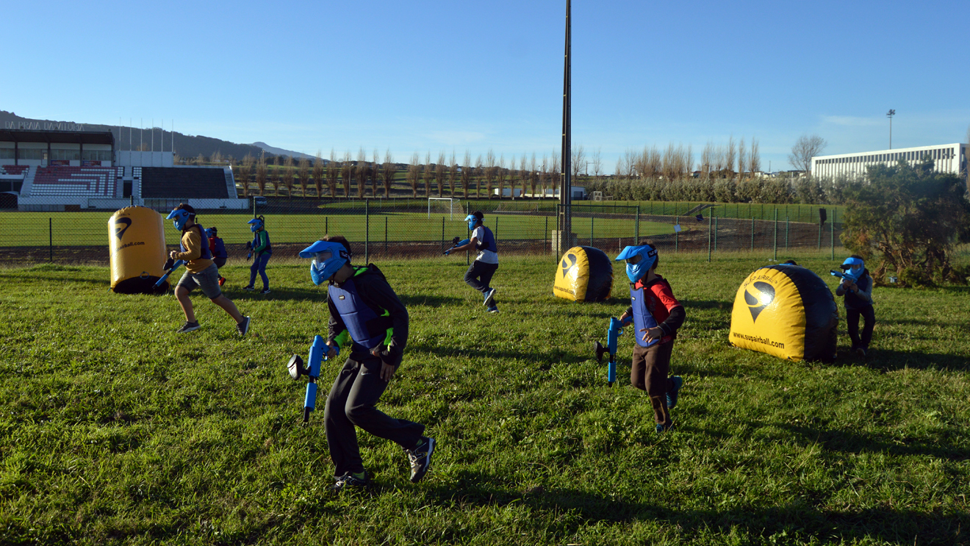

O Clube Júnior propõe um programa de 7 ou 14 dias, na **Colónia de Férias Fechada** **Campo Aventura Júnior Resort.**

**Data do turno 7 dias:** julho: 14 a 20; 28 de julho a 3 agosto; 04 a 10; 11 a 17; 18 a 24; 25 a 31

**Data do turno 14 dias:** 28 de julho a 10 agosto;11 a 24; 17 a 31

**Local:** Quinta do Pegador, em Óbidos

**Quem pode participar:** Filhos e netos de todos **sócios dos** **6 aos 14 anos**

**O que inclui:** Alimentação (pequeno-almoço, lanche, jantar e ceia), transporte, alojamento e diversas atividades (surf, salto, laser tag, karts, mergulho, paintball, slide, escalada, resgate, tiro com arco, espeleologia, karaoke, passeios pedestres, rappel, discoteca, orientação, workshops, GPS, estúdio de TV, zarabatana, piscina, snorkeling, visitas culturais, peddy-papers, praia, jogos noturnos, etc).

No ato da inscrição é necessário **sinalizar** com a 1ª mensalidade.

O pagamento poderá ser fracionado em 6 meses (de maio a outubro).

**Os associados que não optem pelo desconto no vencimento terão de finalizar o pagamento, até à data de início do Campo Aventura.**

|  |  |  |
| --- | --- | --- |
| **Campo Aventura** | **7 Dias** | **14 Dias** |
| **Valor c/comparticipação do GDC** | **390,00 €** | **700,00 €** |
| **Valor p/ público em geral** | **415,00 €** | **735,00 €** |

Lembramos que se por algum motivo houver necessidade de **desistir** teremos que ficar sujeitos às condições impostas pela Colónia/Campo de Férias. Os interessados deverão enviar a inscrição para: [grupo.desportivo.reservas@fidelidade.pt](mailto:grupo.desportivo.reservas@fidelidade.pt)

|  |  |  |  |  |  |  |  |  |  |  |  |  |  |  |  |  |  |  |  |  |  |  |  |  |  |  |  |  |  |  |  |  |  |  |  |  |  |  |  |  |  |  |  |  |  |  |  |  |  |  |  |  |  |  |  |  |  |  |  |  |  |  |  |  |  |  |  |  |  |  |  |  |  |  |  |  |  |  |  |  |  |  |  |  |  |  |  |  |  |  |  |  |  |  |  |  |  |  |  |  |  |  |  |  |  |  |  |  |  |  |  |  |  |  |  |  |  |  |  |  |  |  |  |  |  |  |  |  |  |  |  |  |  |  |  |  |  |  |  |  |  |  |  |  |  |  |  |  |  |  |  |  |  |  |  |  |  |  |  |  |  |  |  |  |  |  |  |  |  |  |  |  |  |  |  |  |  |  |  |  |  |  |  |  |  |  |  |  |  |  |  |  |  |  |  |  |  |
| --- | --- | --- | --- | --- | --- | --- | --- | --- | --- | --- | --- | --- | --- | --- | --- | --- | --- | --- | --- | --- | --- | --- | --- | --- | --- | --- | --- | --- | --- | --- | --- | --- | --- | --- | --- | --- | --- | --- | --- | --- | --- | --- | --- | --- | --- | --- | --- | --- | --- | --- | --- | --- | --- | --- | --- | --- | --- | --- | --- | --- | --- | --- | --- | --- | --- | --- | --- | --- | --- | --- | --- | --- | --- | --- | --- | --- | --- | --- | --- | --- | --- | --- | --- | --- | --- | --- | --- | --- | --- | --- | --- | --- | --- | --- | --- | --- | --- | --- | --- | --- | --- | --- | --- | --- | --- | --- | --- | --- | --- | --- | --- | --- | --- | --- | --- | --- | --- | --- | --- | --- | --- | --- | --- | --- | --- | --- | --- | --- | --- | --- | --- | --- | --- | --- | --- | --- | --- | --- | --- | --- | --- | --- | --- | --- | --- | --- | --- | --- | --- | --- | --- | --- | --- | --- | --- | --- | --- | --- | --- | --- | --- | --- | --- | --- | --- | --- | --- | --- | --- | --- | --- | --- | --- | --- | --- | --- | --- | --- | --- | --- | --- | --- | --- | --- | --- | --- | --- | --- | --- | --- | --- | --- | --- | --- | --- | --- | --- |
| **Ficha de Inscrição – Campo Aventura** | | | | | | | | | | | | | | | | | | | | | | | | | | | | | | | | | | | | | | | | | | | | | | | | | | | | | | | | | | | | | | | | | | | | | | | | | | | | | | | | | | | | | | | | | | | | | | | | | | | | | | | | | | | | | | | | | | | | | | | | | | | | | | | | | | | | | | | | | | | | | | | | | | | | | | | | | | | | | | | | | | | | | | | | | | | | | | | | | | | | | | | | | | | | | | | | | | | | | |
|  | | | |  | | | | | |  | | | |  | | | |  | | | | |  | | | | | | |  | | |  | | | |  | | | |  | | | |  | | | |  | | | |  | | | |  | | | |  | | | |  | | | |  | | | | |  | | |  | | | |  | | | |  | | |  | | |  | | |  | | |  | | |  | | | |  | | |  | | |  | | | |  | | |  | |  | | | |  | | | |  | | | | | | |  | | | | | | | |  | | |  | | |  | | | |  | | | | | | | | |  |  | | | | |  | | |  | | | |  | | | | | | |  | | | | | | | |  | | |  | | |  | | | |
| **Nome:** | | | | | | | | | | | | | | | | | | | | |  | | | | |  | | | | | | | | | | | | | | | | | | | | | | | | | | | | | | | | | | | | | | | | | | | | | | | | | | | | | | | | | | | | | | | | | | | | | | | | | | | | | | | | | | | | | | | | | | | | | | |  | | | | | | | **Nº Colab.:** | | | | | | | | | | | | | | |  | | | | | | | | | | | | | | | | | | | **(Obrigatório)** | | | | | | | | | | | | | | | | | | | | | | | | | | |  | | | | |  | | | |
| **Outros participantes:** | | | | | | | | | | | | | | | | | | | | | | | | | | | | | | | | | | | | | | | | | | | | | | | | | | | | | | | | | | | | |  | | | |  | | | |  | | | | |  | | |  | | | |  | | | |  | | |  | | |  | | |  | | |  | | |  | | | |  | | |  | | |  | | | |  | | | | | | | | |  | | | |  | | | | | | | **Idades** | | | | | | | |  | |  | | | |  | | | | T:\Documentos\Clube Junior\Fitas\fitas.png | | | | | | | | |  |  | | | | |  | | |  | | | |  | | | | | | |  | | | | | | | |  | | |  | | |  | | | | | | | |
|  | | | | | | | | | | | | | | | | | | | | | | | | | | | | | | | | | | | | | | | | | | | | | | | | | | | | | | | | | | | | | | | | | | | | | | | | | | | | | | | | | | | | | | | | | | | | | | | | | | | | | | | | | | | | | | | | | |  | | | | | | | | | | | |  | | | | | | |  | | | | | | | | | | | | | | | | | | | | | | | | | | | | | | | | | | | | | | | | | | | | | | | | |  | | | | |  | | | |
|  | | |  | | | | | |  | | | |  | | | |  | | | | |  | | | | |  | | | | |  | | | |  | | | |  | | | |  | | | |  | | | |  | | | |  | | | |  | | | |  | | | |  | | | |  | | | |  | | | |  | | | |  | | |  | | |  | |  | | |  | | |  | | | |  | | |  | | |  | | | |  | | |  | | |  | | | |  | | | |  | | | | |  | | | | | | | | | | | | | | |  | | |  | | | |  | | | |  | | | | | | |  | | |  | | | |  | | | |  | | | |  | | | | | | |  | | |  | | |  | | |  | | | | | | | |
|  | | | | | | | | | | | | | | | | | | | | | | | | | | | | | | | | | | | | | | | | | | | | | | | | | | | | | | | | | | | | | | | | | | | | | | | | | | | | | | | | | | | | | | | | | | | | | | | | | | | | | | | | | | | | | | | | |  | | | | | | | | | | | |  | | | | | | |  | | | | | | | | | | | | | | | | | | | | | | | | | | | | | | | | | | | | | | | | | | | | | | | | |  | | | | |
|  | | | | | |  | | | | | |  | | | |  | | | |  | | | | |  | | | |  | | | | | |  | | | |  | | | |  | | | |  | | | |  | | | |  | | | |  | | | |  | | | |  | | | |  | | | |  | | | |  | | | |  | | |  | | |  | | | |  | | |  | | |  | | | |  | | |  | | |  | | | |  | | |  | | | |  | | | |  | | | | |  | | | | | | |  | |  | | | | | | | |  | | |  | | | | |  | | | |  | | | | | | |  | | |  | | | |  | | | |  | | | |  | | | | |  | | |  | | |  | | | | |  | | | | | |
|  | | | | | |  | | | | | | | | | | | | | | | | | | | | | | | | | | | | | | | | | | | | | | | | | | | | | | | | | | | | | | | | | | | | | | | | | | | | | | | | | | | | | | | | | | | | | | | | | | | | | | | | | | | | | | | | | | | | | | | | | |  | | | |  | | | | | | | |  | | | | | | | | |  | | | | | | | | | |  | | | | |  | | | |  | | | | | |  | | |  | | | |  | | | |  | | | | | |  | | | |  | | |  | | |  | | | |  | | | | | |
|  | | | | |  | | | | | |  | | | |  | | | |  | | | | |  | | | |  | | | | | |  | | | |  | | | |  | | | |  | | | |  | | | |  | | | |  | | | |  | | | |  | | | | | | |  | |  | | | |  | | | |  | | |  | | |  | | | |  | | |  | | | | |  | |  | | |  | | |  | | | |  | | |  | | | |  | | | | |  | | | | |  | | | | | | |  | |  | | | | | | | |  | | |  | | | | |  | | | |  | | | | | |  | | |  | | | |  | | | |  | | | |  | | | | |  | | |  | | |  | | | | |  | | | | |
|  | **Pagamento:** | | | | | | | | | | | | | | | | | | | | | | | | | | | | | | **Vencimento: maio a outubro** | | | | | | | | | | | | | | | | | | | | | | | | | | | | | | | | | | | | | | | | | | | | | | |  | | | |  | | | | | | | | | | | | | | | | | | | | | | | |  | | |  | | | |  | | | **T. B. – 003521790001079833036** | | | | | | | | | | | | | | | | | | | | | | | | | | | | | | | | | | | | | | | | | | | | | | | | | | | | | | | | | | | | | |  | | | | | |  | | | |  | | |  | | | | |  | | | | | | |
|  | | | | |  | | | | | |  | | | |  | | | |  | | | | |  | | | |  | | | | | |  | | | |  | | | |  | | | |  | | | |  | | | |  | | | |  | | | |  | | | |  | | | |  | | | | |  | | | |  | | | |  | | |  | | |  | | | |  | | |  | | | | |  | |  | | |  | | |  | | | |  | | |  | | | |  | | | | |  | | | | |  | | | | | | |  | |  | | | | | | | |  | | |  | | | | |  | | | |  | | | | | |  | | |  | | | |  | | | |  | | | |  | | | | |  | | |  | | |  | | | | |  | | | | | | |
| **Assinatura:** | | | | | | | | | | | | | | | | | | | | | | | | | | | |  | | | | | | | | | | | | | | | | | | | | | | | | | | | | | | | | | | | | | | | | | | | | | | | | | | | | | | | | | | | | | | | | | | | | | | | | | | | | | | | | | | | **Contacto:** | | | | | | | | | | | | | | | | | | | | | | | |  | | | | | | | | | | | | | | | | | | | | | | | | | | | | **Data:** | | | | | | | | | | | | | | | | | | |  | | | | | | | | | | | | | | | | | | | | |